Health Care Spending Account – VIUFA

As part of your VIU benefit plan, you now have access to a Health Care Spending Account (HCSA) effective January 1, 2024, with an annual entitlement of $280 per employee, single or family. If you are hired after July 1 or have an appointment of less than six months, you will be entitled to $140 for the current year. If you have an extension to your appointment and the duration is greater than 6 months, you will receive a second deposit of $140.00 for a total of $280.00 for the current year. For 2024 only, all eligible Faculty members (active benefit coverage on Feb 1, 2024) will receive an additional amount of $350.

Your eligibility to HCSA benefits is tied to your enrollment under Extended Health Care (EHC) and Dental Care. If you cease to be eligible for EHC and Dental, you will no longer be entitled to the HCSA. Upon cessation of coverage, you may claim for expenses incurred prior to termination which must be claimed within 90 days.

Your HCSA provides flexibility to claim amounts over and above what is covered by your core Extended Health (EHC) and Dental plans, including:
- top-up of claims eligible under EHC or Dental, but not paid at 100% due to deductibles, coinsurance and/or maximums, and
- expenses that qualify under the Medical Expense Tax Credit for income tax purposes, but are not covered by EHC or Dental. A list of eligible expenses may be found here:
Lines 33099 and 33199 – Eligible medical expenses you can claim on your tax return - Canada.ca
Please refer to the following brochure for further details:
HCSA Plan Member Guide - Credit Carryover with COB

The plan year is based on the calendar year. In order to align with Canada Revenue Agency rules, funds credited for any calendar year may be used for expenses incurred during that calendar year, or may be carried forward and used to cover expenses incurred during the subsequent calendar year. Claims must be submitted within 60 days of year end.

For example: Your 2024 entitlement may be used to claim expenses incurred between January 1/24 and December 31/25. Any amount credited for 2024 that is not used by the end of 2025 will forfeit. Claims incurred in 2024 must be submitted by March 1, 2025, to be eligible for payment.

Please note: If you have Coordination of Benefits with a spousal plan, you must claim through both Core EHC/Dental benefits under your VIU plan, and through your spouse’s plan, before you may access funds in your HCSA.

To submit a claim using your Spending Account, select the applicable option at the start of the online claim submission process:
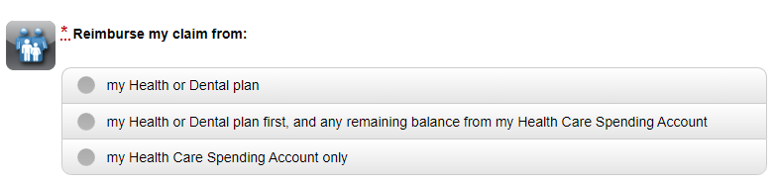

To claim top up from HCSA for claims submitted directly by providers, click on the dollar sign in the second column from the far right on the Manulife plan member site:

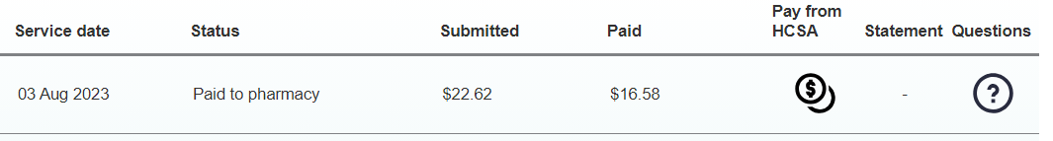

The following window will then pop up. Check the box for “send the unpaid part of this claim to my HCSA” and submit.

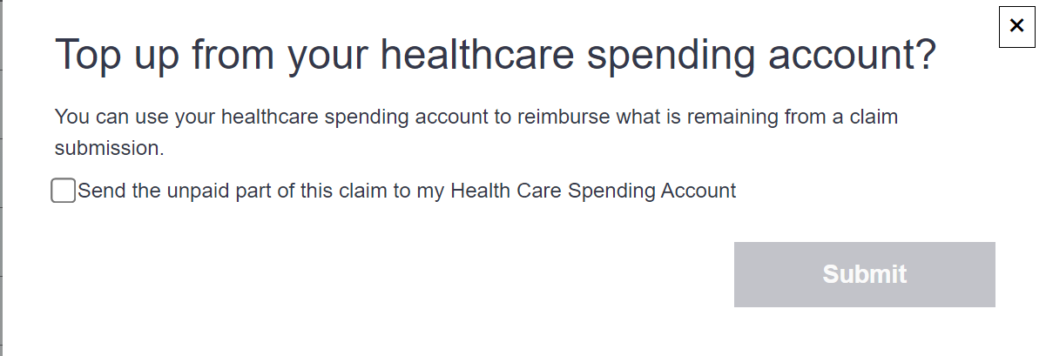

At any time, you can check your remaining balance for the current plan year by clicking the “Coverage and Balances” tab in the middle of the home page, and then selecting “HCSA”, as shown here:

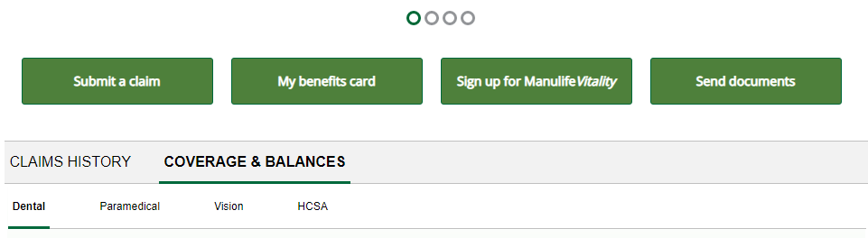

If you have any questions regarding the Health Care Spending Account rules, eligible expenses or how to submit claims, please contact Manulife Group Benefits Customer Service at 1-800-575-2200.

